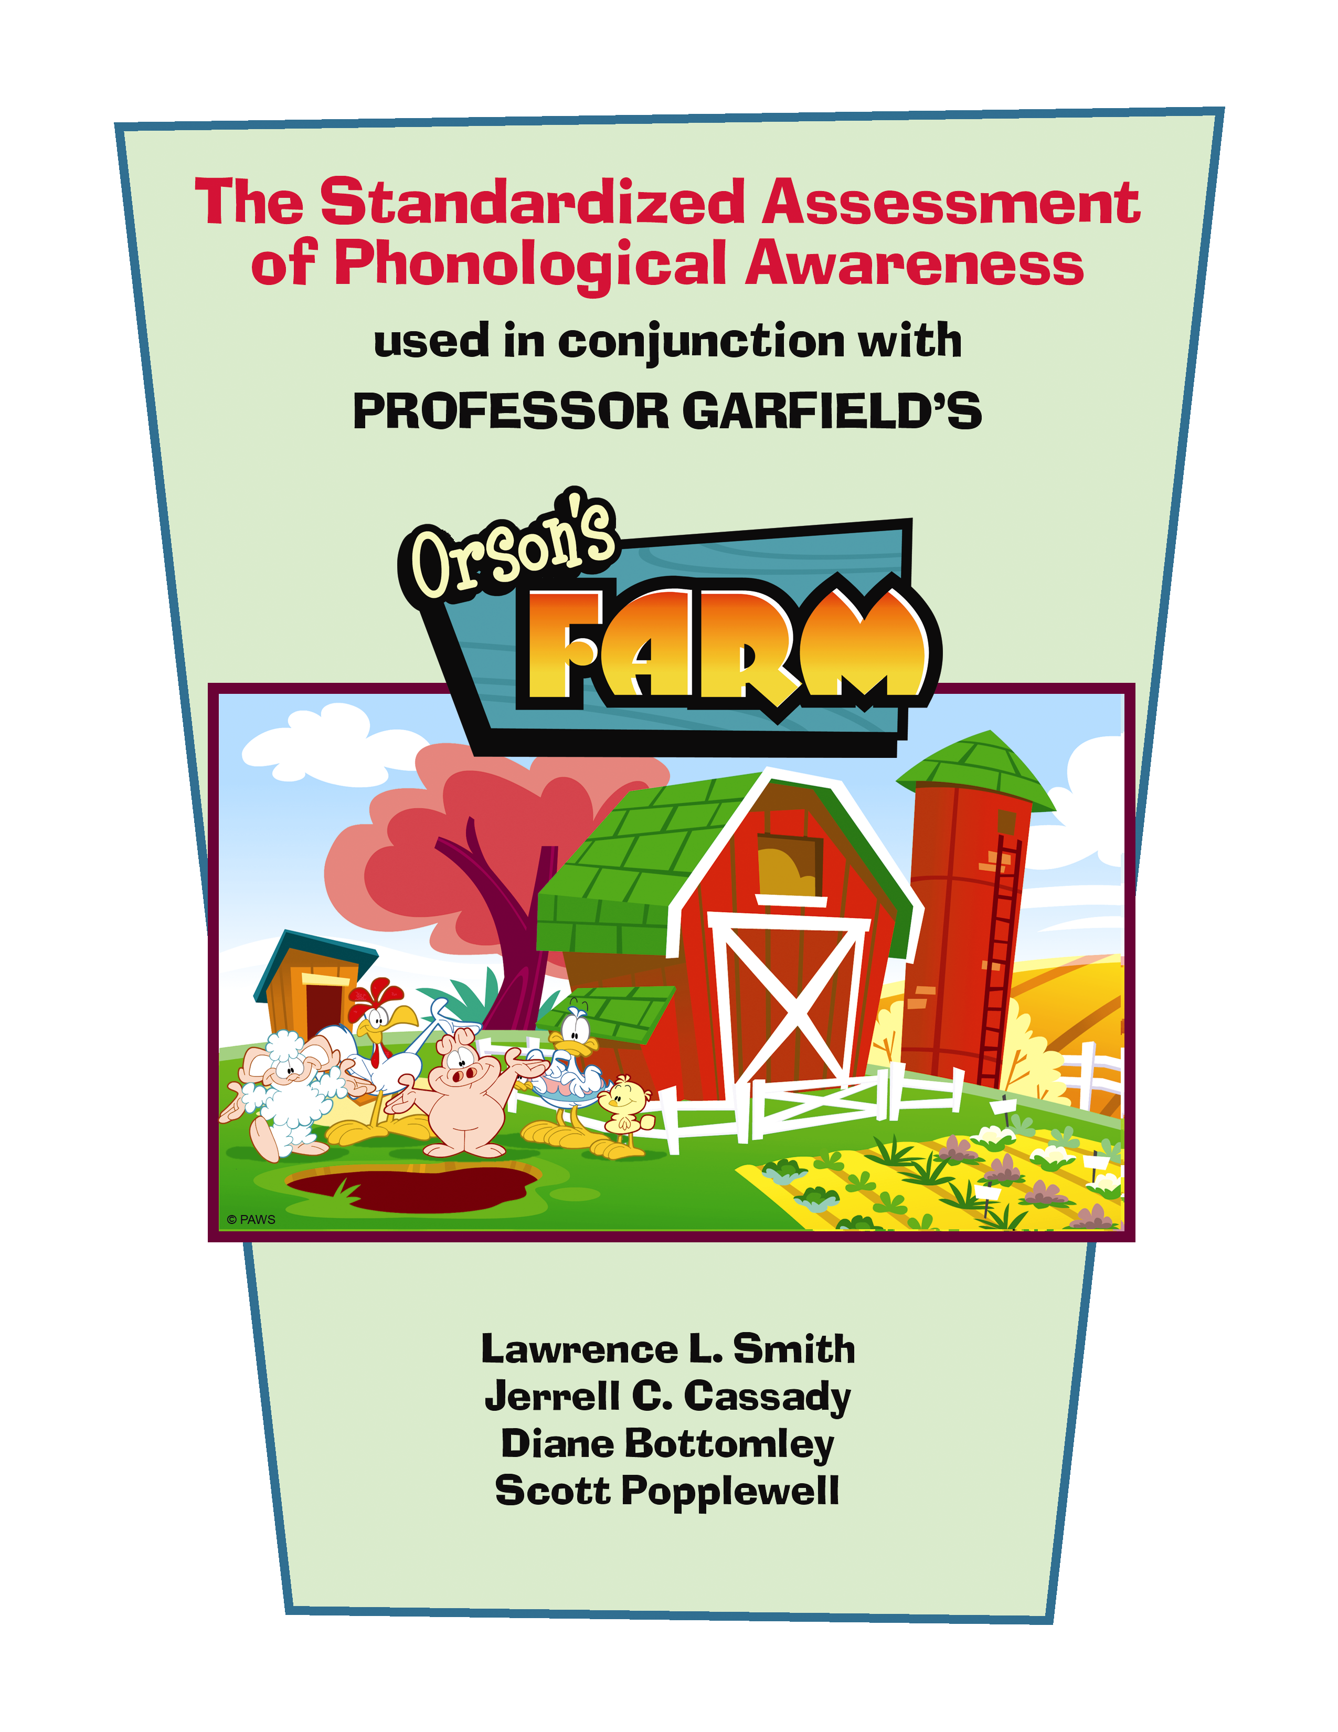
© Ball State University

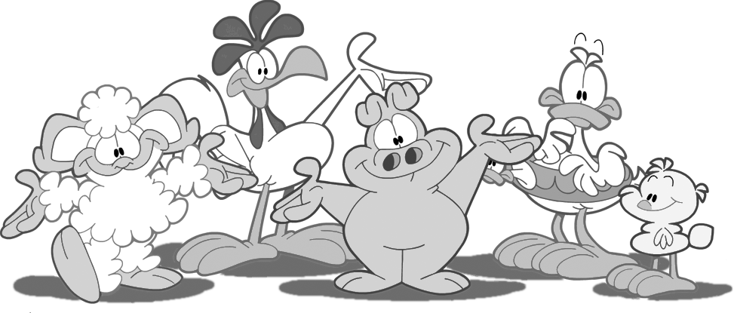

The Standardized Assessment

of Phonological Awareness

Lawrence L. Smith
Jerrell C. Cassady
Diane Bottomley
Scott Popplewell

Teachers College
Ball State University
Muncie, Indiana 47306

For further information, contact Lawrence L. Smith at lsmith@bsu.edu

© Ball State University
Garfield Characters © PAWS, Inc 2007

The contents of this article were developed under a subgrant from the U.S. Department of Education. However, such contents do not necessarily represent the policy of the U.S. Department of Education, and you should not assume endorsement of the Federal Government, Project Funding Authority; Part B, IDEA Project Number 14204-001-DY08.

Table of Contents

Authors’ Note…………………………………………………………. 4

SAPA Detailed Protocol and Administration Instructions …………… 5
SAPA Scoring Sheet…………………………………………………... 20

Authors’ Note
Our work in providing teachers with instructional support in the earliest stages of reading development repeatedly highlighted the need to have a user-friendly assessment instrument that teachers could rely upon when attempting to gain fast, yet reliable, information on the level of phonological awareness exhibited by their students. The intention of this project was to provide teachers with the tools necessary to isolate specific phonological awareness activities that were problematic for their learners so that focused instructional attention could be directed toward those areas of need most readily, ideally unlocking the potential for the learners’ growth.
This project has led to the progressive development of what is now the Standardized Assessment of Phonological Awareness. Over the course of the project, we have had the help of many teachers and research assistants. We hold deep appreciation for the feedback from all the teachers who were instrumental in revisions of the SAPA. Furthermore, we wish to acknowledge the insightful and formative assistance of over the years we were engaged in developing this product: Felicia Jordan, Dr. Kathy Bauserman, Dr. Kathryn Edmunds, Dr. Linda Huber, and Dr. Carolyn Walker.
For information regarding the validity of SAPA, we refer you to the following article:
Cassady, Jerrell C., Smith, Lawrence L. & Huber, Linda K. (2005). Enhancing Validity in Phonological Awareness Assessment through Computer-Supported Testing. Practical Assessment Research & Evaluation, 10(18). Available online: http://pareonline.net/getvn.asp?v=10&n=18

RHYMING SUBSET (RR & RA)
© Ball State University

The initial skill developed in phonological awareness is typically considered to be sensitivity to rhymes. In the rhyming subset, the focus is on the child’s ability to determine if two words rhyme as well as the ability to generate novel rhymes upon command.

Rhyme Recognition (RR)

Administration Notes: The student response to these items differs from the other subtests, as the answer is only a yes/no distinction. In the Response Column, you can circle the stated response by the child. For ease in scoring later, the correct response has been bolded in the scoring sheet.

Instructions: Two words rhyme when they have they sound the same at the end. Bat rhymes with cat; man rhymes with can. Does book rhyme with cup? No, book and cup do not rhyme because book ends with /ook/ and cup ends with /up/. Next, I am going to say some words. Tell me if they rhyme. [Practice item: hive – dive; rat – snow].

Rhyme Recognition (RR)
 | Item | Response | Score
P1 | hive-dive | YES NO | Correct ___
P2 | rat-snow | YES NO | Correct ___
1 | dip-hip | YES NO | Score
2 | rag-wall | YES NO
3 | ape-knee | YES NO
4 | bake-lake | YES NO
5 | rink-sink | YES NO
 | TOTAL |  | /5

NOTES:
Rhyme Application (RA)

Administration Notes: Responses to rhyme must include more than the ending of the given word. For instance, when prompted with “Jam,” the response “am” is not an accurate rhyme response. In this instance only, you can prompt for another rhyming word. Nonsense words are acceptable responses. You may also find writing the actual response in the provided space in the scoring box to be useful in doing task analyses that explore error patterns across children or over time.

Instructions: Remember that rhyming words are two words that sound the same at the end. I’m going to give you a word and then you will tell me a word that rhymes with it. Let’s begin: Tell me a word that rhymes with . [Practice items: star, nose]

Rhyme Application (RA)
 | Item | Response | Score
P3 | star |  | Correct ___
P4 | nose |  | Correct ___
6 | jam
7 | take
8 | ball
9 | mouse
10 | wing
 | TOTAL |  | /5

NOTES:

ODDITY DETECTION SUBSET

The oddity detection subset involves the learner identifying the “odd word out” by focusing on one specific phonemic position in a set of three words. The subset involves isolating the beginning, end, then middle sounds to determine which word is not similar to the rest of the list. During the administration of the oddity test items, the child will see a set of pictures to represent the words to reduce the strain on working memory. If the child states that the picture represents a different word, assure the child that “in this case, we want the picture to mean _____.” You may find that it helps to be able to point to the picture that is being read.

The item is scored correctly if the child identifies the word in any fashion (verbally or by touching the picture as a response). If the child indicates that the “second item” is the one with a different sound, have the child confirm which picture or word they mean (e.g., Can you point to the second one for me?). To score each item, the administrator first circles the choice made by the student in the Item Column of the scoring sheet. The score is then entered as standard.

Oddity Tasks—Beginning Sounds (OBS)

Administration Notes: This task requires the student to identify the word with a different beginning sound. It is important to first identify what a “beginning sound” is to the child. For instance “A beginning sound is the first sound in a word.”

Instructions: You are going to see a set of 3 pictures. Then, the names of the pictures are going to be read. Listen to the names of these pictures and tell which one has a different beginning sound. The beginning sound is the first sound in the word. For example: which one has a different beginning sound? nest, soap, nails. Soap has a different beginning sound.

Oddity Tasks – Beginning Sounds (OBS)
 | Item | Score
P5 | leaf, map, lamp | Correct ___
P6 | fork, bed, fish | Correct ___
11 | duck, door, foot
12 | goat, book, gum
13 | ring, jet, rope
14 | well, wig, coat
15 | rug, yawn, yell
 | TOTAL | /5

NOTES:
Oddity Tasks—Ending Sounds (OES)

Administration Notes: This task requires the student to identify the word with a different ending sound. Verify knowledge that “ending sound” means the last sound of a word before proceeding to actual test items.

Instructions: You are going to see a set of 3 pictures. Then, the names of the pictures are going to be read. Listen to the names of these pictures and tell which one has a different ending sound. The ending sound is the last sound of a word. For example: which one has a different ending sound bell, web, crib? Bell has a different ending sound.

Oddity Tasks – Ending Sounds (OES)
 | Item | Score
P7 | cane, sun, watch | Correct ___
P8 | seal, cat, mail | Correct ___
16 | tub, rake, lock
17 | comb, ham, box
18 | map, house, goose
19 | road, game, sled
20 | jug, log, gate
 | TOTAL | /5

NOTES:
Oddity Tasks—Middle Sounds (OMS)

Administration Notes: This final oddity task requires the student to identify the word with a different middle sound. In all items, the middle sound is a vowel sound for this task.

Instructions: You are going to see a set of 3 pictures. Then, the names of the pictures are going to be read. This time, listen to the names of the pictures and tell which one has a different middle sound. For example: which one has a different middle sound beak, cone, heel? Cone has a different middle sound.

Oddity Tasks – Middle Sounds (OMS)
 | Item | Score
P9 | jack, cap, run | Correct ___
P10 | roof, tape, cake | Correct ___
21 | bug, rock, sun
22 | pack, six, lid
23 | hop, fin, sock
24 | bike, feet, vine
25 | tube, cape, rain
 | TOTAL | /5

NOTES:

BLENDING SUBSET

The blending subset focuses on the child’s ability to bring together component sounds in spoken language and provide the complete word without breaks and pauses. In the blending tasks, the standard prompt is “Tell me the word I have when I put these sounds together.”

The delivery of the items has been controlled such that the sounds are separated by 1 second. Assure the child that the space between the items is on purpose if they question the long pause. There are two example items to provide prior to the actual practice items. For the example items, the administrator provides the answer, not the child. Write the stated answer in the Response column, and score the item in the Score column.

Blending Body-Coda (BBC)

Administration Notes: This task assesses the ability to form a word when it has been segmented into the body and coda. Body is the part of the word starting from the beginning and carrying through the vowel, while coda is the part of the word that comes after the vowel (eg. Cat = /ca/ /t/).

Instructions: I am going to say a word in two parts. When you have heard both parts of the word, you need to say what the whole word is. For example: /pee/--PAUSE-- /k/ makes the word “peek.” Another example is /moa/ --PAUSE-- /t/ makes the word “ moat.”

Blending Body-Coda (BBC)
 | Item | Response | Score
P13 | bea /d/ |  | Correct ___
P14 | pa /n/ |  | Correct ___
31 | ra /ck/
32 | no /te/
33 | tu /g/
34 | mi /ss/
35 | sho /p/
 | TOTAL |  | /5

NOTES:
Blending Onset-Rimes (BOR)

Administration Notes: This blending task requires bringing together the onset and the rime. In a single-syllable word (as is the case with all these items) the onset is the part of the word that precedes the vowel, while rime includes everything from the vowel on.

Instructions: I am going to say a word in two parts. When you have heard both parts of the word, you need to say what the whole word is. For example: /r/ --PAUSE-- /un/ makes the word “run.” Another example is /s/ --PAUSE-- /et/ makes the word “set.”

Blending Onset-Rimes (BOR)
 | Item | Response | Score
P11 | /t/ all |  | Correct ___
P12 | /w/ eek |  | Correct ___
26 | /n/ ap
27 | /t/ an
28 | /m/ utt
29 | /b/ ill
30 | /p/ en
 | TOTAL |  | /5

NOTES:
Blending Phonemes (BP)

Administration Notes: The blending phonemes task requires the child to synthesize or blend each sound in the word. For the SAPA, all BP items are consonant-vowel-consonant sound items, hence the BP task requires blending 3 phonemes.

Instructions: I am going to say a word in parts. When you have hard all the parts of the word, you need to say what the whole word is. For example: /s/--PAUSE-/u/--PAUSE-- /n/ makes the word “sun.”

Blending Phonemes (BP)
 | Item | Response | Score
P15 | /s/ /a/ /ve/ |  | Correct ___
P16 | /j/ /o/ /ke/ |  | Correct ___
36 | /k/ /ee/ /p/
37 | /p/ /e/ /t/
38 | /s/ /a/ /ck/
39 | /n/ /o/ /t/
40 | /k/ /i/ /te/
 | TOTAL |  | /5

NOTES:

SEGMENTING SUBSET

The segmenting subset is the natural contrast to the blending tasks. In this subset, the student is given the task of segmenting either at the onset-rime or phoneme level. There is no segmenting body-coda task. In determining if a successful segmentation has been made, it is merely required that the child’s response has made an observable break in the word at the targeted location. In the practice items, if the child is segmenting at the wrong location (e.g., after the vowel instead of before the vowel on the onset-rime items), then corrective feedback is appropriate.

Segmenting Onset-Rimes (SOR)

Administration Notes: This task requires the student to take words apart by saying the first sound (onset) and then the rest of the word (rime). Care in scoring is warranted for this task. If children are over-segmenting by identifying all phonemic breaks, you can repeat the direction that they should break it into only two parts. Because the focus is on the ability to break the word into component phonological parts, when a child identifies all phonemic parts in the item it should not be marked as incorrect, but should be identified on the scoring protocol with a note.

Instructions: I am going to read a word to you. You need to break that word up into two parts by saying the first sound of the word and then the rest of the word. For example, I can separate the word “name” by saying the first sound /n/ and then the rest of the word /ame/.

Segmenting Onset-Rimes (SOR)
 | Item | Response | Score
P17 | boat |  | Correct ___
P18 | wet |  | Correct ___
41 | lap
42 | jet
43 | sit
44 | cob
45 | make
 | TOTAL |  | /5

NOTES:

Segmenting Phonemes (SP)

Administration Notes: This task requires the child to analyze or segment each sound in a word. Given that all items on the SAPA are C-V-C words, the correct response for all SP tasks should include three distinct sounds. If a child segments at only the onset-rime level, the item is to be marked as inaccurate. You can prompt during the practice items to break these words up into ALL the different sounds. To be marked accurate, the answer should be the phonemic sound created by a letter, not the name of a letter.

Instructions: I am going to read a word to you. After you hear the word, you need to say each sound you hear in the word. For example, if I say each sound in the word “came,” it is /c/ /--PAUSE-- /a//--PAUSE-- /me/.

Segmenting Phonemes (SP)
 | Item | Response | Score
P19 | Sad |  | Correct ___
P20 | Dog |  | Correct ___
46 | job
47 | led
48 | rose
49 | bug
50 | kid
 | TOTAL |  | /5

NOTES:

PHONEMIC MANIPULATION SUBSET

As mentioned earlier, there are a variety of SAPA subsets that can be derived based on the theoretical position adopted with respect to phonological awareness acquisition. The final subset we outline here involves the greatest level of phonological manipulation required by the SAPA. The three tasks require isolating phonemes and making changes to the word at the phoneme level. These tasks include both deletion and substitution. In these three subtests, the learner is required to mentally manipulate the word sounds to produce a new word or portion of a word.

Phoneme Deletion (PD)

Administration Notes: In the assessment of phoneme deletion, the correct responses include only those where the individual can generate just the word portion that is requested, keeping the “deleted” portion out of their response. In these items, all deletions occur at the initial sound location and the resultant answer is a non-word.

Instructions: I am going to read you a word and ask you to tell me what the word would sound like if I took away the first sound in the word. For example, listen to the word tab. If you take away the /t/ sound, only /ab/ is left.

Phoneme Deletion (PD)
 | Item | Response | Score
P21 | book-- /b/ |  | Correct ___
P22 | yes-- /y/ |  | Correct ___
51 | tap-- /t/
52 | pain-- /p/
53 | rug-- /r/
54 | mop-- /m/
55 | sight-- /s/
 | TOTAL |  | /5

NOTES:

Phoneme substitution—Beginning Sounds (BS)

Administration Notes: This subtest requires the learner to replace the first phoneme sound of a given word with a new sound. It is an extension of the PD task prior, and care in ensuring the child is clear that the task requires adding the new sound to the beginning in addition to deleting the first sound is important. The standard prompt is “change the first sound in ____ to ___. What is the new word?” All items lead to an existing word.

Instructions: I am going to read you a word, then ask you to change the first sound in that word to make a new word. For example, if I say the word man and change the first sound to /p/, the new word is pan.

Phoneme Substitution—Beginning Sounds (BS)
 | Item | Response | Score
P23 | cat to /h/ |  | Correct ___
P24 | lay to /s/ |  | Correct ___
56 | rock to /l/
57 | jeep to /k/
58 | cash to /r/
59 | bake to /f/
60 | moon to /s/
 | TOTAL |  | /5

NOTES:
Phoneme Substitution—Ending Sounds (ES).

Administration Notes: As in the BS phoneme substitution task, the child is prompted to replace one phonemic unit in this task. Care needs to be taken that the child is focusing on the last, or ending sound in the task. In the practice items, it is important to correct the error to replace the first sound through guided feedback (e.g., “remember, we are trying to change the LAST sound in the word this time”).

Instructions: I am going to read you a word, then ask you to change the last sound in that word to make a new word. For example, if I say the word can and change the last sound to /p/, the new word is cap.

Phoneme Substitution—Ending Sounds (ES)
 | Item | Response | Score
P25 | rat-- /g/ |  | Correct ___
P26 | his-- /t/ |  | Correct ___
61 | cut-- /p/
62 | back-- /t/
63 | soap-- /k/
64 | tip-- /n/
65 | pig-- /ll/
 | TOTAL |  | /5

NOTES:
Phoneme Substitution—Middle Sounds (MS)

Administration Notes: As in the other two phoneme substitution tasks, the child is prompted to replace one phonemic unit. Again, care needs to be taken that the child is focusing on the middle sound in the task. In the practice items, it is important to correct the error to replace the first or last sound through guided feedback (e.g., “remember, we are trying to change the MIDDLE sound in the word this time”).

Instructions: I am going to read you a word, then ask you to change the middle sound in that word to make a new word. For example, if I say the word pan, change the middle sound to /i/, the new word is pin.

Phoneme Substitution—Middle Sounds (MS)
 | Item | Response | Score
P27 | cat-- /o/ |  | Correct ___
P28 | zip-- /a/ |  | Correct ___
66 | bud-- /e/
67 | fan-- /i/
68 | net-- /u/
69 | jig-- /o/
70 | pot-- /a/
 | TOTAL |  | /5

NOTES:

SAPA Scoring Sheet
Rhyme Recognition (RR)
 | Item | Response | Score
P1 | hive-dive | YES NO | Correct ___
P2 | rat-snow | YES NO | Correct ___
1 | dip-hip | YES NO | Score
2 | rag-wall | YES NO
3 | ape-knee | YES NO
4 | bake-lake | YES NO
5 | rink-sink | YES NO
 | TOTAL |  | /5

Rhyme Application (RA)
 | Item | Response | Score
P3 | star |  | Correct ___
P4 | nose |  | Correct ___
6 | jam
7 | take
8 | ball
9 | mouse
10 | wing
 | TOTAL |  | /5

Oddity Tasks – Beginning Sounds (OBS)
 | Item | Score
P5 | leaf, map, lamp | Correct ___
P6 | fork, bed, fish | Correct ___
11 | duck, door, foot
12 | goat, book, gum
13 | ring, jet, rope
14 | well, wig, coat
15 | rug, yawn, yell
 | TOTAL | /5

Oddity Tasks – Ending Sounds (OES)
 | Item | Score
P7 | cane, sun, watch | Correct ___
P8 | seal, cat, mail | Correct ___
16 | tub, rake, lock
17 | comb, ham, box
18 | map, house, goose
19 | road, game, sled
20 | jug, log, gate
 | TOTAL | /5

Oddity Tasks – Middle Sounds (OMS)
 | Item | Score
P9 | jack, cap, run | Correct ___
P10 | roof, tape, cake | Correct ___
21 | bug, rock, sun
22 | pack, six, lid
23 | hop, fin, sock
24 | bike, feet, vine
25 | tube, cape, rain
 | TOTAL | /5

Blending Body-Coda (BBC)
 | Item | Response | Score
P13 | bea /d/ |  | Correct ___
P14 | pa /n/ |  | Correct ___
31 | ra /ck/
32 | no /te/
33 | tu /g/
34 | mi /ss/
35 | sho /p/
 | TOTAL |  | /5

Blending Onset-Rimes (BOR)
 | Item | Response | Score
P11 | /t/ all |  | Correct ___
P12 | /w/ eek |  | Correct ___
26 | /n/ ap
27 | /t/ an
28 | /m/ utt
29 | /b/ ill
30 | /p/ en
 | TOTAL |  | /5

Blending Phonemes (BP)
 | Item | Response | Score
P15 | /s/ /a/ /ve/ |  | Correct ___
P16 | /j/ /o/ /ke/ |  | Correct ___
36 | /k/ /ee/ /p/
37 | /p/ /e/ /t/
38 | /s/ /a/ /ck/
39 | /n/ /o/ /t/
40 | /k/ /i/ /te/
 | TOTAL |  | /5

Segmenting Onset-Rimes (SOR)
 | Item | Response | Score
P17 | boat |  | Correct ___
P18 | wet |  | Correct ___
41 | lap
42 | jet
43 | sit
44 | cob
45 | make
 | TOTAL |  | /5

Segmenting Phonemes (SP)
 | Item | Response | Score
P19 | Sad |  | Correct ___
P20 | Dog |  | Correct ___
46 | job
47 | led
48 | rose
49 | bug
50 | kid
 | TOTAL |  | /5

Phoneme Deletion (PD)
 | Item | Response | Score
P21 | book-- /b/ |  | Correct ___
P22 | yes-- /y/ |  | Correct ___
51 | tap-- /t/
52 | pain-- /p/
53 | rug-- /r/
54 | mop-- /m/
55 | sight-- /s/
 | TOTAL |  | /5

Phoneme Substitution—Beginning Sounds (BS)
 | Item | Response | Score
P23 | cat to /h/ |  | Correct ___
P24 | lay to /s/ |  | Correct ___
56 | rock to /l/
57 | jeep to /k/
58 | cash to /r/
59 | bake to /f/
60 | moon to /s/
 | TOTAL |  | /5

Phoneme Substitution—Ending Sounds (ES)
 | Item | Response | Score
P25 | rat-- /g/ |  | Correct ___
P26 | his-- /t/ |  | Correct ___
61 | cut-- /p/
62 | back-- /t/
63 | soap-- /k/
64 | tip-- /n/
65 | pig-- /ll/
 | TOTAL |  | /5

Phoneme Substitution—Middle Sounds (MS)
 | Item | Response | Score
P27 | cat-- /o/ |  | Correct ___
P28 | zip-- /a/ |  | Correct ___
66 | bud-- /e/
67 | fan-- /i/
68 | net-- /u/
69 | jig-- /o/
70 | pot-- /a/
 | TOTAL |  | /5

